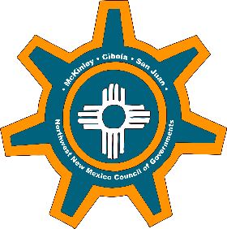
Developing a Community Grant Program
"10 Steps for Setting Up an AWESOME Community Grant Program”
- Review the Community’s Master Plans, Land Use Plans, Comprehensive Plan and ICIP priorities.
- Meet with Department Heads or key officials and staff to determine and prioritize needs, projects, and goals.
- Meet with the Northwest NM Council of Governments.
- Produce and review a list/database of current grants and past applications that were applied and/or awarded.
  - Get copies of application and produce a database including all partners in those grants.
  - Determine an average success/win rate over last five years that you can compete with or measure yourself against.
  - Probably can start with Manager or Grants and Contracts personnel, if one exists.
- Develop a stellar but boilerplate introduction that can be used for any and all grants proposals to explain where you are and who you are.
- Compile all general background, contact, and grant information including all Federal and State tax ID information, DUNS#, SAM #, user names, and passcodes.
- Funding Opportunities: Look at NM Catalog of Assistance (outdated but some usefulness still) and use Grants.gov and check daily for opportunities and create customized searches and notifications.
- Institute and implement a grant research and management system through email newsletters, webinars, Grants.gov, and other sites (e.g. NM Grant Plant).
- Self-Training and powerpoints on grantwriting tips: http://www.slideshare.net/
- Intervene other like communities and long-term, successful grantwriters to steal what they do, templates and winning applications, success they have had, and funding sources that they pull in that yours doesn’t.
Roll out your sleeves and learn from your mistake.
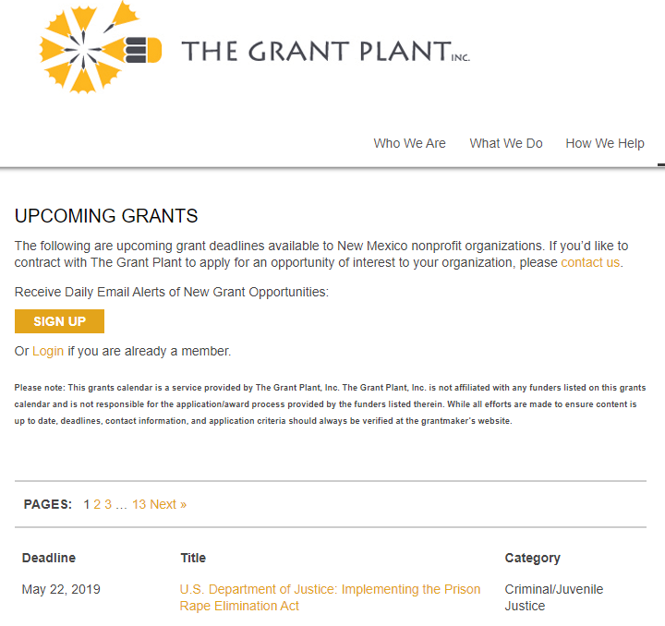
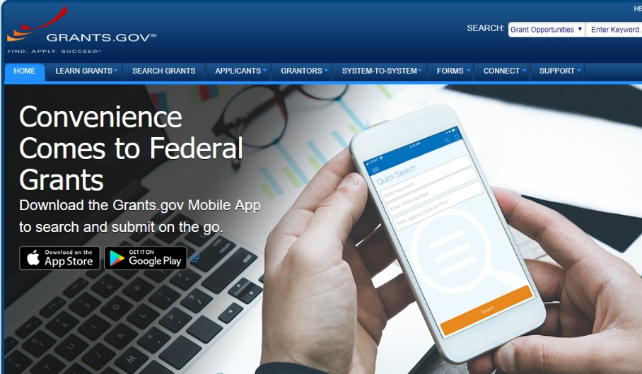
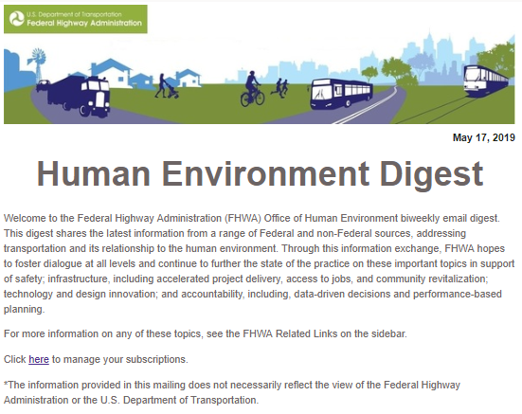
Grant Finders
Email Subscriptions

